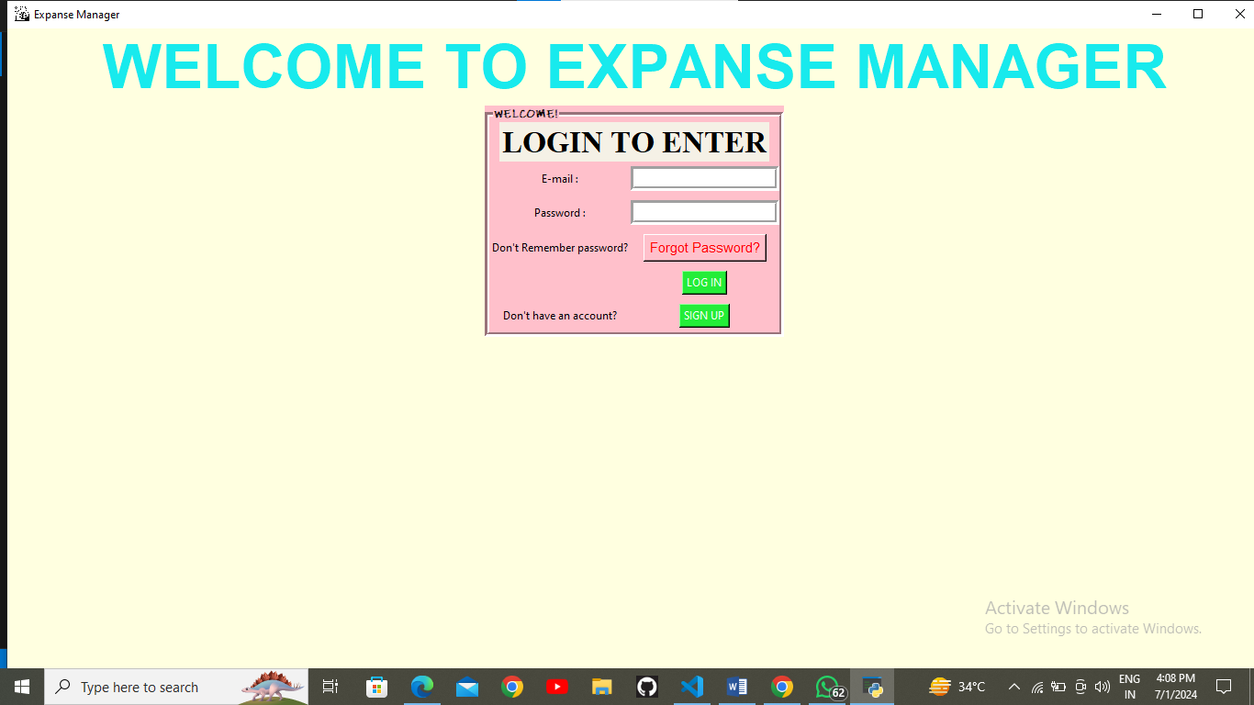

**Fig.** Login page of Expense Manager.

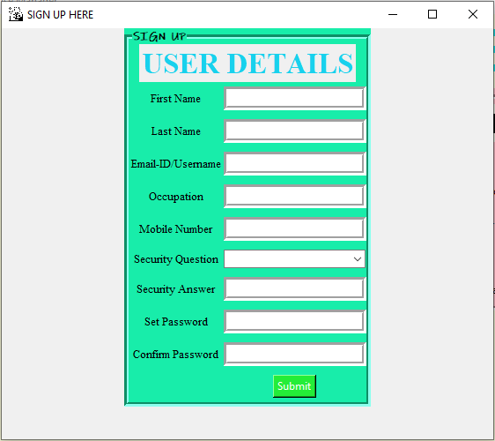

**Fig.** Sign Up page to create your account for new users.

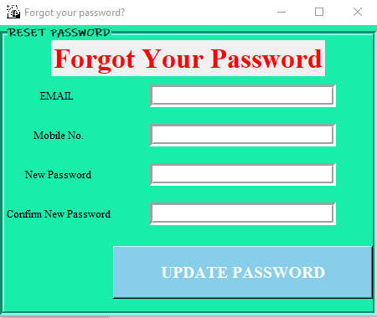

**Fig.** Page to update your password if you forget.



**Fig .**  Enter your correct E-mail & password to login successfully

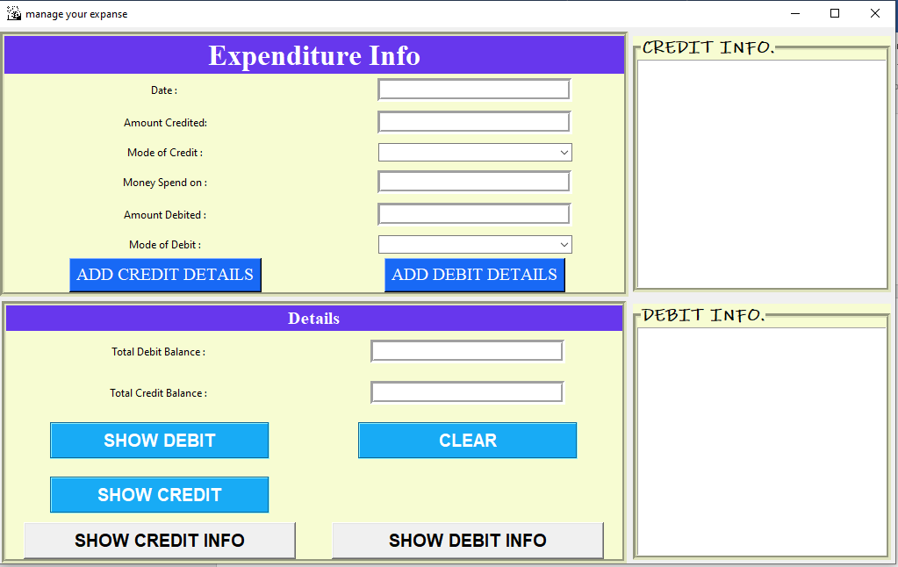

**Fig.** Main page of Expense Manager to manage your Expanse.

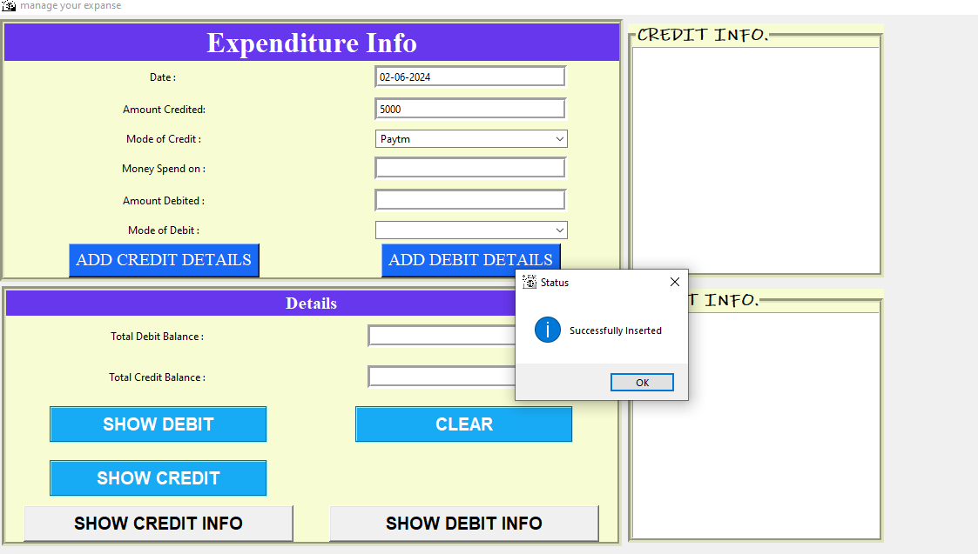

**Fig.** To add the credited amount

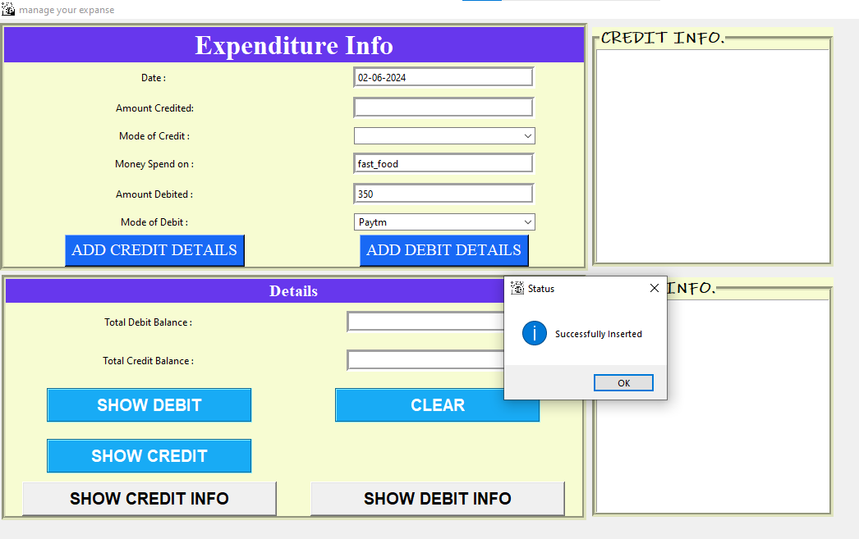

**Fig**. To add the Debit amount

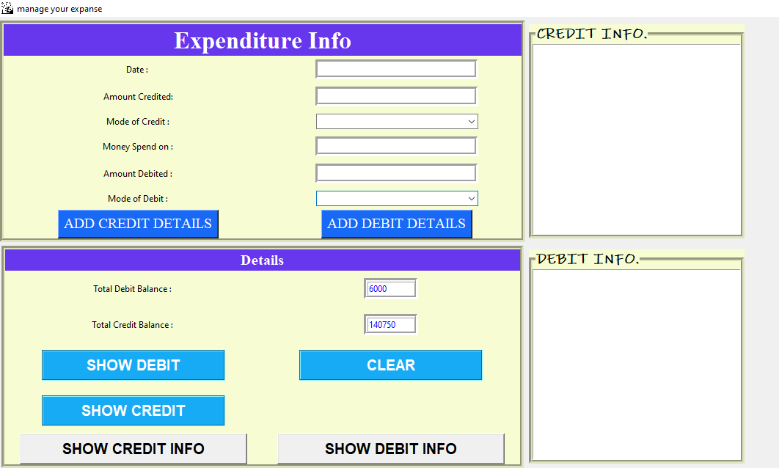

**Fig.** To show the total debited and credited balance.

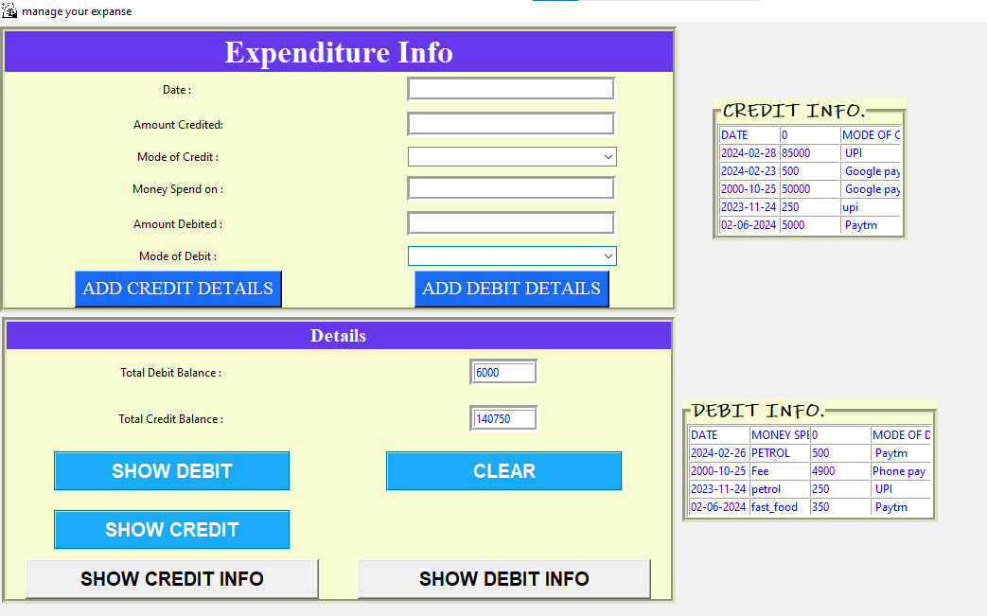

**Fig.** To get the brief info about the credit and debit balance.